TEACHING UNIVERSITY STUDENTS WHAT PLAGIARISM IS, [ESPECIALLY IN ACADEMIC WRITING]

** An electronic version of this document is posted at http://www.csc.kth.se/~kristina/plagiat/2.html **

There are many ways to teach students what the word ‘plagiarism’ means in written work. Usually, teaching happens towards the start of a student’s university study.

Most students need several opportunities to learn about plagiarism combined in different ways. Students will need additional teaching and practice in order to know how to avoid plagiarism by being skilful writers.

Teaching through guidance, leaflets and policy statements

- Telling students what is not allowed

Many university documents just forbid plagiarism as in this example, aimed at Engineers:
Plagiarism is mentioned
here
Engineers shall prepare articles for the lay or technical press which are only factual.
Technical Communications for publication (theses, articles, papers, reports,etc.) which are based on research involving more than one individual (including students and supervising faculty, industrial supervisor/researcher or other co-workers) must recognize all significant contributors. Co-authors listed on proposed and accepted publications should have entered the joint authorship arrangement by mutual consent prior to submittal of the document for publication and should have received written permission to use any unpublished work of others which serves as the major basis or key component of the publication.
Technical Communications should adhere to clearly defined and appropriately disseminated guidelines on authorship. These guidelines should be promulgated and publicized in corporate, university or other employer policies and should take cognizance of professional technical society recommendations on ethical practice.
Plagiarism, the act of substantially using another's ideas or written materials without due credit, is unethical.

Forbidding plagiarism does not help students know what to do so on its own,
it cannot be considered as a way of teaching.

- Providing a description of unacceptable practice

Many good examples are found around Swedish universities. For example, the Department of Economic History at Lund University issues students with a letter which they sign. The letter gives examples of how work could be unacceptable. This helps students begin to understand what they must do.
[A copy of the letter is in Appendix 1 of this booklet and is posted on the seminar website, http://www.csc.kth.se/~kristina/plagiat/2.html

- Providing statements in Programme Handbooks and in course PMs about plagiarism

These statements are usually in Swedish but some programmes also have an English version. Such statements are rarely read by anyone and would not be considered by most Disciplinary Boards as evidence that a student who has been reported for plagiarism had been informed of their responsibilities. Statements in handbooks are useful resources in teaching sessions about plagiarism – for example, students could be asked to read them and to rewrite them in their own words - but do not in themselves teach students what plagiarism is.

- Providing leaflets, posters and reminders for students

Many universities in Sweden produce specialist leaflets. Some are only about examinations, some about a range of skills including academic writing and referencing. It is helpful to have guidance on referencing in hard copy so students can consult it when writing on screen.

An impressive series of publications which can be downloaded in PDF format can be found at http://academicintegrity.curtin.edu.au/studentbook.html. There is also a lecture using Flash.

- Running special events and ‘plagiarism weeks’

The University of Saskatchewan runs regular ‘Plagiarism weeks’ www.usask.ca/honesty/week.shtml.

- Using news stories and press releases

An example from the University of Saskatchewan in 2005 is included in Appendix 2. This example uses numbers of cases found.

Teaching about plagiarism through lectures and specialist sessions in students’ courses

Many Swedish university Libraries offer special sessions and additional information.

- The UK Write Now project provides Powerpoint slides and activities for student workshops. . http://www.writenow.ac.uk/student_authorship.html

Teaching through activities and discussion-starters

This kind of session concentrates on students’ ability to distinguish between unacceptable and acceptable ways to create assignments. These activities need to be done interactively. Additional time is needed for asking questions and for discussing any issues that arise from the activity.

Examples of activities which help students develop ther knowledge about plagiarism:

- Showing examples of students’ work

A collection of examples, some modified to show particular aspects of plagiarism, could be used. Students could diagnose the mistakes or they could decide which pieces of work are likely to receive a good mark and which might be reported for plagiarism.

- The ‘Collusion Continuum’ exercise.

[A copy is provided in the booklet for HSV Seminar 1, December 15, 2008 and again, on the seminar series website http://www.csc.kth.se/~kristina/plagiat/2.html

- The ‘Is it plagiarism?’ activity

Students in small groups can be asked to classify a set of actions as ‘acceptable’, as ‘fabrication /falsification of data’, and as ‘plagiarism’.
[A copy of this exercise is in Appendix 3 and on the seminar series website http://www.csc.kth.se/~kristina/plagiat/2.html

- The ‘Draw the Line’ exercise

[A copy was provided in HSV Seminar 1 booklet , 15 December 2008 and is on the seminar series website, http://www.csc.kth.se/~kristina/plagiat/2.html

Teaching through cover sheets and signed statements

The Lund Department of Economic History example (see above and Appendix 1) includes a section where students sign they have understood.

- The cover-sheet checklist

Student are asked to tick a list of statements and to sign that the work they are handing in is their own work. See Appendix 4 for an example and the seminar website http://www.csc.kth.se/~kristina/plagiat/2.html

Teaching through on-line tutorials

Some universities require students to show they have completed tutorials before they submit any home examinations assignments. A few of the sites below provide ‘attendance’ evidence but this can be done by using the university’s own log in site for access to the tutorial. Examples of tutorials;

- Three Swedish universities (Kalmar, Växjö and Bleckinge) have combined to create a site (one version is on http://www.bi.hik.se/Refero/1intro.php ). The site includes self-test quiz material. The original material for the Swedish sites comes from http://tutorials.sjlibrary.org/tutorial/plagiarism/

- The Acknowledgement site, based in Australia, offers a wide range of guidance to teachers and students, including several on line quizzes.
http://calt.monash.edu.au/staff-teaching/plagiarism/acknowledgement/about/index.html

- Many commercial products offer tuition in plagiarism. One example is called PLATO and has been developed by the University of Derby, UK. http://www.i4learn.co.uk/edu_HEproducts.html

- The Library site at Arcadia University, Canada offers a widely-used tutorial
http://library.acadiau.ca/tutorials/plagiarism/

Teaching through websites and on-line guidance

There are dozens of such sites and new ones pop up all the time. Some of the Swedish examples are mentioned in the last section.
Important: Students are unlikely to go to such sites unless required to do so. Some universities require students to show they have completed tutorials before they submit their first home examination.

- The Library site at Lund University offers several guidance notes and links to study skills sites.
http://www.lub.lu.se/en/student/academic-integrity/what-is-plagiarism.html

- The Rutgers University site uses a game-show format for teaching about plagiarism. http://library.camden.rutgers.edu/EducationalModule/Plagiarism/whatisplagiarism.html

- The University of Southern Queensland has a wide range of study skills support. http://www.usq.edu.au/library/help/ehelp/ref_guides/default.htm

Teaching through blogs

The University of Saskatchewan, Canada runs a blog where anyone can discuss issues linked to plagiarism and academic honesty.
See http://blogs.usask.ca/integrity/2008/09/plagiarism_beyo.html

APPENDIX 1
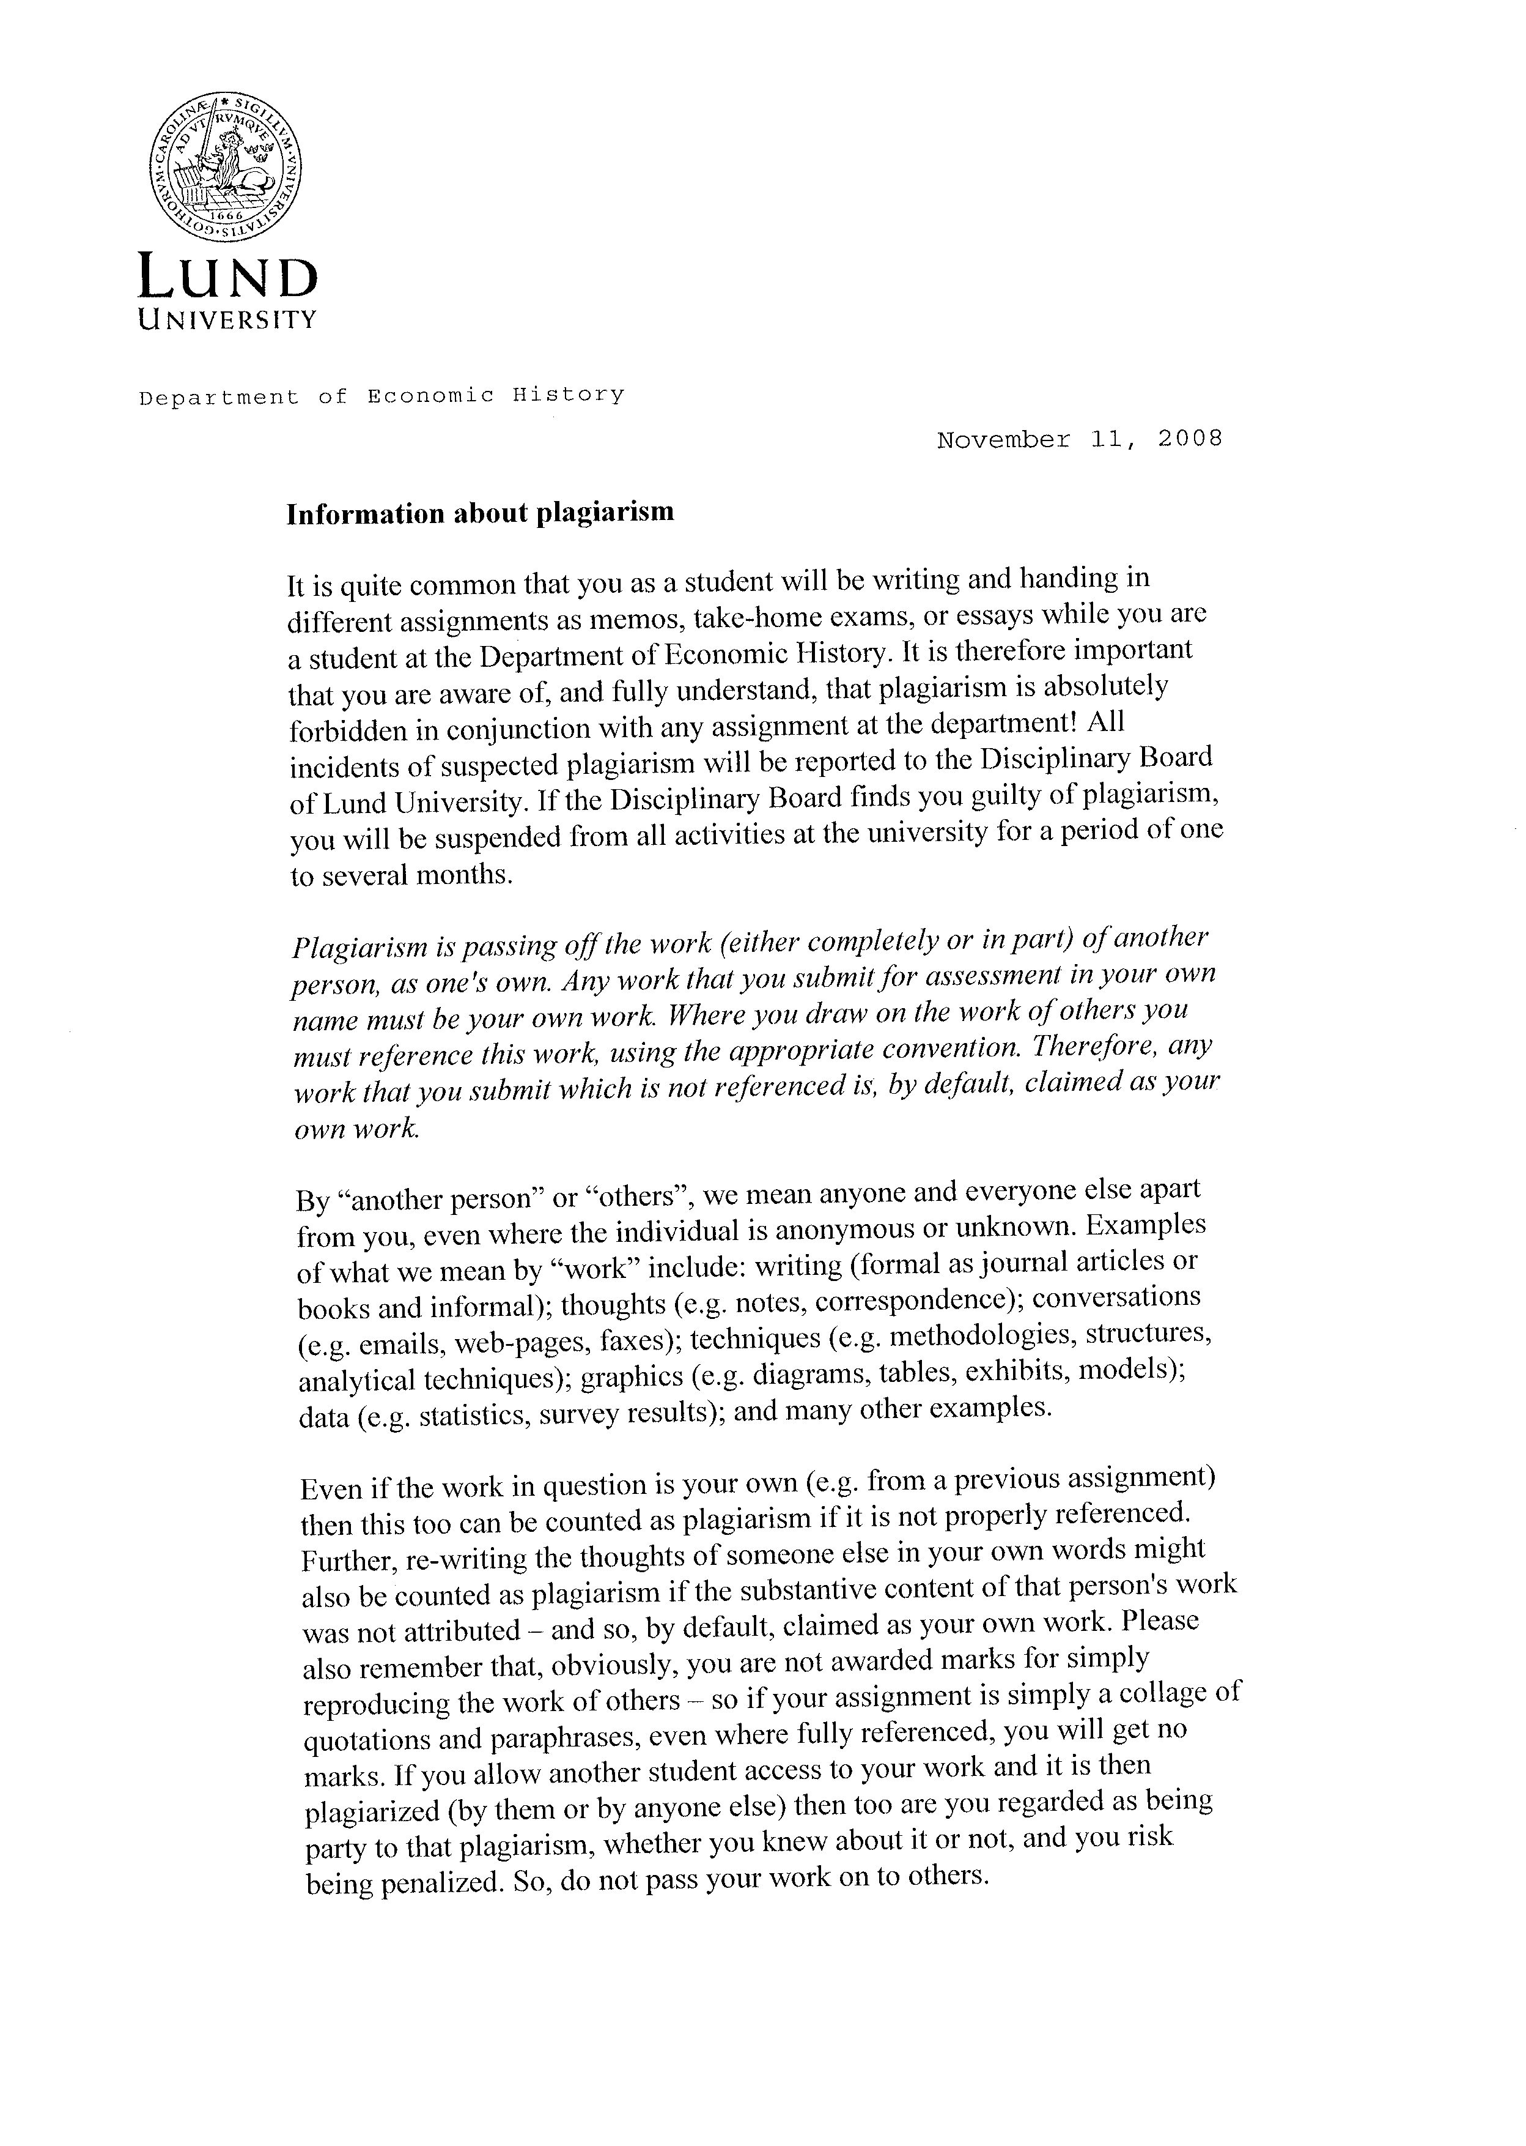
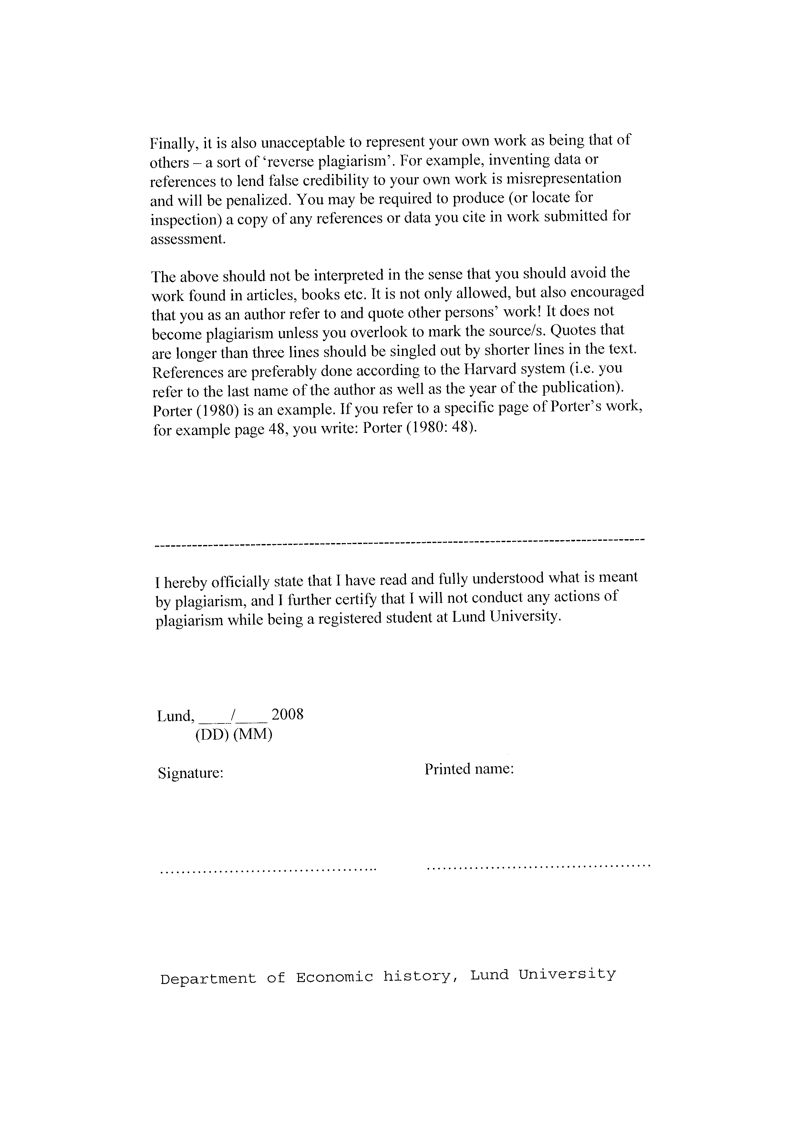
APPENDIX 2: PRESS RELEASE, University of Saskatchewan

FOR IMMEDIATE RELEASE - Oct. 27, 2005
Statistics Show Reduction in Plagiarism Cases at U of S
Today, the University of Saskatchewan released its annual set of statistics on cheating, showing that for the third consecutive year, the number of cases has dropped.
University Secretary Lea Pennock announced that between July 2004 and June 2005, the University had 52 cases of academic dishonesty heard by college and university panels. Of these, 47 students were found to be guilty (one student was suspended for a term, none were expelled, and the remainder were penalized with either failure in the class or with a grade reduction in the class).
“The reduction in cases this year appears to be due primarily to fewer charges of plagiarism, in contrast to other types of academic dishonesty,” said Pennock. “Last year there were 45 plagiarism cases while this year there were fewer than 30.”

This is the third year that the University has released its academic dishonesty statistics. In 2002-03, there were 79 cases heard, of which 67 were found to be guilty, while in 2003-04, there were 73 cases heard, of which 60 were found to be guilty.
“The U of S takes a proactive approach in educating students about honesty and integrity so that their degrees are earned honestly and are respected by their future employers,” added Pennock. “The University has focused particular attention on plagiarism issues over the last three years and I am very pleased to see that our hard work is paying off.”
Faculty discuss plagiarism issues in class, and information about plagiarism and cheating is included in class outlines. The University Secretary’s Office began a campaign in 2002 using the catchphrase “Writing It Right” to educate students about plagiarism and provide resources so that students could cite sources correctly when writing essays.
Another improvement made at the U of S last year deals with the problem of copying laboratory assignments. A new procedure developed by computer science professor Mark Eramian, was used in computer science classes to educate students about the importance of doing their own software assignments.
The computer science department uses one of two software detection programs to identify similarities in software writing assignments in computing and computer science courses. A departmental panel, which includes a student representative, then determines whether a warning letter should be sent to
alert the student that they should not be sharing software writing with other students. Last year, 105 warning letters were sent; only two students became repeat offenders who were then charged with plagiarism.
Monday, Oct. 31 marks the beginning of the University’s third annual Writing It Right Week, where lunchtime sessions educate students and faculty about the importance of honesty and integrity.
Writing it Right Week activities run daily through to Nov. 4.
Additional information can be found at www.usask.ca/honesty/week.shtml
APPENDIX 3 : An activity to trigger discussion

Is it plagiarism ? [submitting someone else’s work as your own]
Is it fabrication? [creating something that is not true]
Is it cheating? [seeking an unfair advantage]

- You say you are ill in order to get more time to do an assignment. In fact, you are not ill.

- You are doing a research project. You collect all the data for your project, you analyse the data, and you decide what it means. You give the analysed data plus your notes about what it means to someone else. That other person writes up your data using the standard template for reporting. That other person also writes the ‘discussion section’ from your notes. You hand in the result.

- The teacher gives you a homework problem. You find the solution in a book and copy it.

- You download four pages off the Web then you make lots of changes to the ‘download’ so that it is more relevant to the examination topic. You rewrite more than half of it. Luckily, the original site had a bibliography. You use the bibliography and add 4 more recent sources because the bibliography was a bit dated. You hand in a six page paper + the new bibliography.

- You ask someone to proof read and correct your essay before you hand it in. The proof reader only changes the language, not the structure or the ideas. He also corrects any language where the meaning could be misunderstood. You hand in the corrected version.

- You ask an experienced programmer to look at your code. She corrects only the standard parts that are used in many programmes and explains what must be done in the complex parts to make it work. You do not understand her explanation so the ‘expert’ fixes the complex parts, too. You hand in the result.
- You write in your own words about a complicated idea that you found in a book. Your writing describes the idea that you found and you write what the idea means. You put the name of the author and the name of the book in the list of sources at the end of your paper. This reference is the only sign in your written assignment that you used this book and this idea.
- You find an author who says exactly what you wanted to say in your essay. You copy that ‘just what I wanted to say’ bit into your assignment. Then, immediately after the copied bit, you write about your opinion ( ‘I agree with what Brown says here about this…’. ). You list the book by Brown in your bibliography.
APPENDIX 4: Sample Cover sheet for students’ assignments

[Students would be asked to complete and sign this sheet and attach it to their home examination paper.]

In creating this assignment, I certify that:

- This submission represents my own work.

- Where I have worked with others (including fellow students) in making this assignment, I have followed any guidance in the assignment for acknowledging others’ contribution.

- Where I have used others’ words (for example, from the Internet, text books, journals or other sources), I have always shown the quotation clearly by measures such as quotation marks, italics or indented paragraphs.

- Where I have used others’ ideas, images or tables (for example, from the Internet, books, journals, lecture notes or other sources), I have indicated this at the point where others’ words, images and/or ideas are used.

- To acknowledge others’ words or ideas, I have used the referencing system recommended by the department. I have shown how sources are used in the text itself ( for example, by footnotes or in – text citation).

- I have listed all the sources I used in this work in my bibliography.

- My bibliography is written according to the department’s referencing guidelines. I have followed recommendations for the order and punctuation of each item.

- I know what is meant by plagiarism and have taken all reasonable steps in this work to avoid it.

