Implementation Theory

- Most strategic solutions lack a clear structure, and even when one exists the players perceptions of the situation do not necessary coincide with an “objective” description.

- Planner sets the rules of the interaction, and individuals are assumed to take them literally but the planner does not control players’ preferences or actions.

- The planner starts with a description of desirable outcomes and maps them to the preference profiles

- Realisation of the objectives with players assuming that their behaviour conforms with the solution concept

- Planner can force individuals to play the game but cannot enforce the desirable outcome directly

- Planner does not have information which other all other players have (symmetric information)

Definition: Choice rule is a function that assigns a subset of feasible outcomes to each profile in a set of preference profiles.

Planner’s environment

- A finite set of N players, with N > 1

- A set C (outcomes)

- A set P (preference profiles over C)

- A set G of game forms with consequences in C

Definition: Solution concept = set valued function S with domain G x P
Such that S takes values of action profiles in strategic game and in extensive game it takes values in the set of terminal histories

Definition: S-implementable game in planners environment if for choice rule f there is a function g(S(G,≥)=f(≥)

Definition: The strategic game G truthfully S-implements the choice rule f if for every preference profile in P we have situation where every player reports the true preference profile is a solution of the game)

Nash implementation

Game form :

- Each player has to announce a preference profile

- For any preference profile true telling is a Nash equilibrium (Both prisoners confess??)

If a choice rule is Nash implementable then it is truthfully Nash implementable (natural equilibrium).

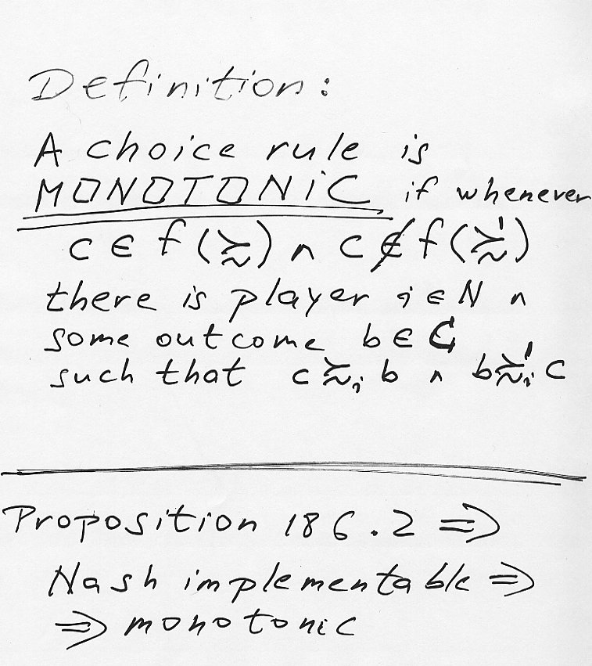

(Monotonic <=> Nash implementable according to the following example)

Solomons predicament in strategic game

Let:

Outcomes:
a= baby given to mother 1
b= baby given to mother 2
d= baby cut in parts

Possible preference profiles:

θ(1 is the real mother): a >₁ b >₁ d and b >₂ d >₂ a

θ’(2 is the real mother): a >’₁ d >’₁ b and b >’₂ a >’₂ d

There is not outcome y such that a ≥_{I} y and y ≥’_{I} a => Choice rule f defined by f(θ)={a} and f(θ’)={b} is not monotonic (=> not Nash implementable)

